Lesson 3 Demo 8: Inspect, Remove, and Prune an Image

This section will guide you to:

* Inspect a Docker image
* Remove a Docker image
* Prune untagged Docker images

**Step 1:** Use the following command to pull the *nginx* image from Docker Hub:

*sudo docker pull nginx:latest*

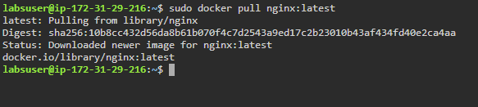

**Step 2:** Use the following command to inspect a Docker image:

*sudo docker image inspect nginx:latest*

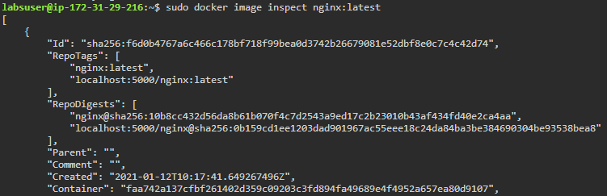

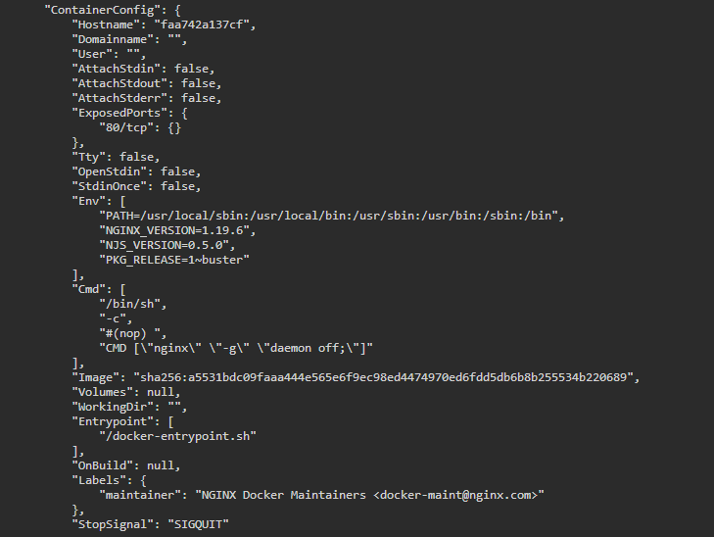

**Step 3:** Use the following command to list all the running images:

*sudo docker images*

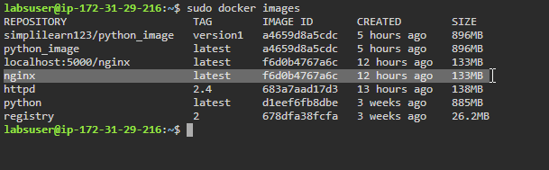

**Step 4:** Use the following command to remove an image:

*sudo docker image rm IMAGE_ID*

***Note:*** *Replace IMAGE_ID with Id of the image you wish to delete*

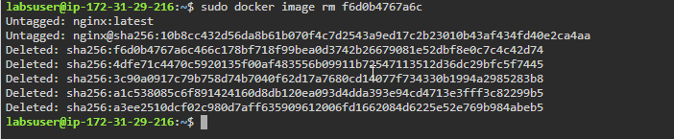

**Step 5:** Use the following command to force remove an image:

*sudo docker image rm --force IMAGE_ID*

***Note:*** *Replace IMAGE_ID with Id of the image you wish to delete forcefully*

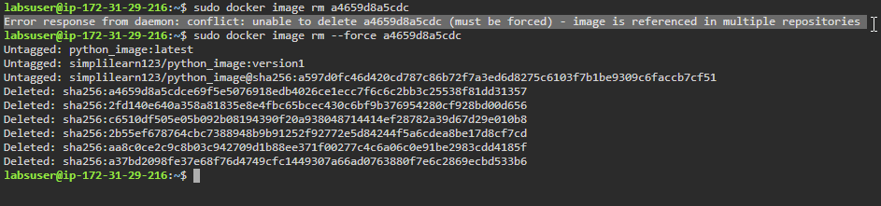

**Step 6:** Use the following command to remove all untagged images:

*sudo docker image prune --all*

